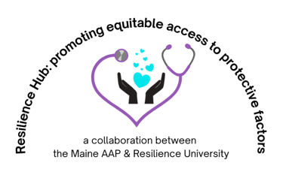

Resiliency Resources for Parents

Parent Support:
G.E.A.R. Parent Network: family support network for parents whose children have behavioral issues https://gearparentnetwork.org/
Child Care Choices: providing families with a searchable database for childcare choices as well as resources about what to look for in a good childcare setting https://www.childcarechoices.me/
Maine Autism Society: support and community for families of children with Autism https://www.asmonline.org/
Maine Parent Federation: support for families of children with special needs https://www.mpf.org/
NAMI Family Support Groups: peer-led support group for any adult with a loved one who has experienced symptoms of a mental health condition https://www.nami.org/Support-Education/Support-Groups/NAMI-Family-Support-Group
NEABPD Family Connections Program: based on research funded by the National Institute of Mental Health. Survey data from previous courses show that after completing the course, family members experience decreased feelings of depression, burden, and grief, and more feelings of empowermenthttps://www.borderlinepersonalitydisorder.org/family-connections/
Maine Crisis: if you or a loved one is experiencing a mental health crisis, you can call 988 or access one of the many options (hotline, warmline, crisis assessment, and more) at https://namimaine.org/crisis-resources/

Parenting Resources:
Triple P “Positive Parenting Program” highly studied, created by a psychologist in Australia; may be available in your community https://www.triplep.net/glo-en/home/
AAP “Special Time:” suggestions on how to implement this for parents https://downloads.aap.org/AAP/PDF/Family_SpecialTime.pdf
Resilience Building Ideas for Parents: the Center for the Study of Social Policy put together a website and downloadable PDF guide for parents https://cssp.org/building-resilience-in-troubled-times-a-guide-for-parents/

Parenting Books:
The Whole Brained Child Dan Siegel & Tina Bryson
Brain-Body Parenting Mona Delahook

Social Media Resources:
Sparks video series: videos for each developmental stage to help parents connect with their kids https://www.sparksvideoseries.com/
UMass Chan Medical School videos for parents: https://www.umassmed.edu/cttc/pair-a-docs-video-series/
@Doctor_Pianka: Founder of Resiliency university and authoring a book on the topic for the national AAP, Maine Pediatrician Dr. Pianka brings tips for resilience to you via Instagram, TikTok, Facebook and YouTube

