Maine’s Children and Youth with Special Health Care Needs
Monthly Learning Series



Mission: Improve the health and quality of life for children with special health care needs and their families.

G.E.A.R Parent Network
May 5, 2026, 3:30-4:30pm
Please Register Here
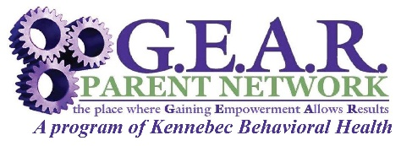

In this webinar learn about the G.E.A.R. Parent Network and its grassroots efforts to become a family organization in 1992 offering phone support and support groups to parents, and the evolution in its mission to support Maine parents and caregivers who are raising children/youth with emotional and behavioral healthcare needs. In 2013 the Family Peer Specialist role evolved from being one of not only providing emotional support and resource sharing, to today in reducing parental feelings of isolation as well as increasing parental knowledge and skill building that builds family protective factors, resiliency and strength while honoring parent voice and choice. Join us to learn more about this totally family run organization that offers no cost short and long-term family peer support, and the data that supports the many benefits that credentialled Family Peer Specialists offer to both the family and service delivery system.

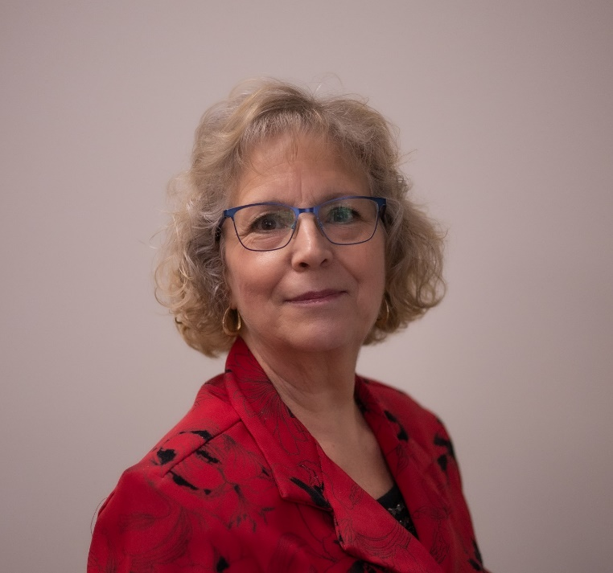
Cindy Seekins, CFPS, G.E.A.R. Parent Network Director - Cindy is a parent who raised her children with behavioral health concerns, and has been employed with G.E.A.R. Parent Network for the past 25 years and as the Director for the past 12 years. As one of Maine’s parent pioneers, Cindy is passionate about her work to support families in getting their children’s behavioral health needs met and to educate providers of the many challenges that families face in raising a child or youth with behavioral health concerns. Cindy has actively worked over the past 30+ years with providers, legislators, federal and state officials advocating to improve Maine’s Behavioral Healthcare system to ensure it is timely, family driven, youth guided, culturally and linguistically competent. She often quotes that “If we truly value our children, we uplift their parents.”
In April of 2008, the Maine Chapter of the National Association of Social Workers selected Cindy as the recipient of the NASW “2007 Public Citizen of the Year” award recognizing her “outstanding work, passion, motivation and inspiration, along with her dedication and commitment to working with agencies to bridge the gaps that sometimes exists between providers and families.” As well as in November of 2008 the “Advocacy Award” on behalf of KidsPeace of New England and the Alliance for Children and Families.
In 2014 Cindy was credentialled through the National Federation of Families Certification Commission as a Certified Family Peer Specialist and in 2025 became certified in PEARLS through the UCONN Innovations Institute. Cindy is a member of the Maine Alliance of Family Organizations (MAFO), the National Federation of Families (NFFCMH) and the Family Run Executive Directors Leadership Association (FREDLA). She is trained in Trauma Informed Care, the Parenting With Dignity® and Nurturing Parent programs, as well as the Restorative Practices Model through the International Institute of Restorative Practice.
Cindy’s past professional work background have been in Administration, Human Resources, Mental Health licensing & Quality Assurance for several Maine social services agencies. Cindy and her husband have been married for 38 years and have a blended family of 4 sons, 11 grandchildren and 3 great grandchildren.
The Children and Youth with Special Health Care Needs, Health Care Coordinator provides a unique resource for families, providers, and communities. The goal is to assist families and providers in finding services that will help the child or youth acquire optimal health, development, well-being, and the best quality of life.
To learn more please visit us at:
https://www.maine.gov/dhhs/mecdc/population-health/mch/cshn/
Email: MCH.CDC@maine.gov
Phone: 207-287-5357
TTY users call Maine relay 711

DHHS NON-DISCRIMINATION NOTICE
The Department of Health and Human Services complies with applicable Federal and State civil rights laws and does not discriminate on the basis of disability, race, color, sex, gender, sexual orientation, age, national origin, religious or political belief, ancestry, familial or marital status, genetic information, association, previous assertion of a claim or right, or whistleblower activity, in admission or access to, or the operation of its policies, services, or activities, or in hiring or employment practices.




